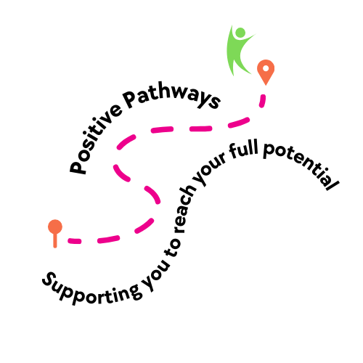

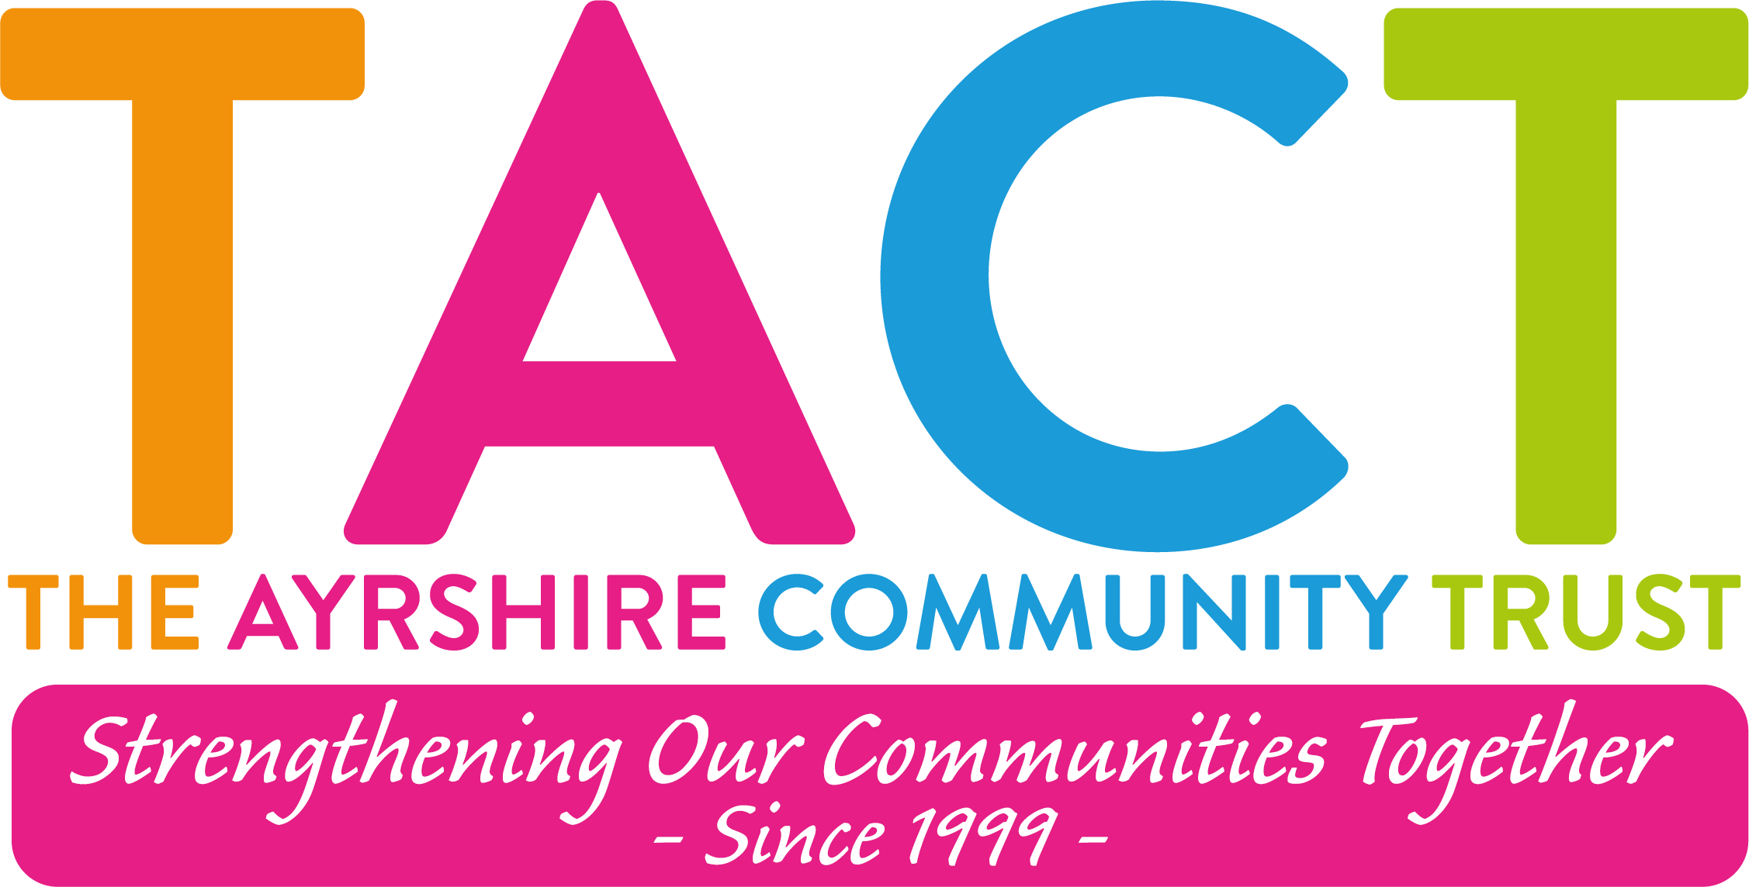

The Ayrshire Community Trust

Job Description

Post: Employability Placement Worker
Responsible to: Employability Team Leader
Salary: £24,052 - £25,600
Hours: 35 hours (Please Note: Normal working week Monday - Thursday with occasional evening and weekend work)
Location: Vernon Street, Saltcoats
Contract: Temporary Contract until July 2026 (with potential of extension depending on funding)

Employee Benefits:
- Real Living Wage Employer
- Four Day Working Week (Monday to Thursday)
- 8% Employer Pension Contributions (after probationary period)
- Access to Employee Supported Volunteering
- Carer Positive Employer
- Disability Confident Employer
- Access to Flexible Working
- Death in Service Benefit

About:
The Ayrshire Community Trust is a charity based in North Ayrshire that provides programmes and projects that make a difference to people’s lives by encouraging, supporting and promoting community action.

Positive Pathways is an Employability Programme supporting unemployed people to reach their full potential through Personal Development Workshops, Volunteering Placements, Coaching and skill enhancing E-Learning opportunities.

Person Specification:
As an Employability Placement Worker, you will be responsible for supporting the progression from training to volunteering placement and job opportunities. The programme targets unemployed individuals, aiming to gain skills, experience, and confidence through volunteering placements and job opportunities. You will also be tasked with administrative duties and liaising with external partners to build pathways to employment.

Summary of Main Responsibilities:

Delivery:
- Assess individual participants’ progression needs and tailor support accordingly.
- Lead workshops and group sessions to prepare participants for future opportunities, such as volunteering placements and job roles aligned with their interests.
- Promote the project to potential recruiters, partner services, and volunteer involving organisations through presentations, networking, and direct outreach.
- Work both one-on-one and in group settings with participants to provide tailored support and guidance on employability skills and co-ordinating placement visits.
- Monitor and record each participant's progress.
- Collaborate with team members to ensure seamless project delivery.
- Work towards agreed targets related to employment outcomes and progression strategies.
- Liaise with partner services, ensuring the development of meaningful partnerships that support participant progression into volunteering or paid job roles.

Development and Innovation:
- Proactively devise innovative routes to enhance employability and volunteer progression.
- Review and develop current volunteer placement opportunities and explore sustainable job roles or apprenticeships tailored to participants to improve their experience.
- Share new ideas and contribute to discussions to enhance the delivery of the project and create better outcomes for participants.
- Stay responsive to organisational changes and adapt programme delivery accordingly.
- Build and nurture new relationships with local businesses, charities, and community partners to increase job and volunteer placement opportunities.
- Collaborate with internal colleagues and external partners to enhance the development and delivery of employability programmes.

Quality Assurance:
- Increase the number of successful progression outcomes (volunteer placements or paid employment).
- Foster professional relationships with staff, volunteers, external organisations, and potential employers.
- Set a professional example in areas such as dress code, personal hygiene, punctuality, and attendance.
- Stay proactive in addressing matters of Health & Safety and Child Protection; report any concerns to the Employability Team Leader.
- Attend regular supervision, team meetings, and staff development days.
- Regularly gather and review feedback from participants to improve programme quality and effectiveness.
- Uphold the organisation’s codes of conduct and ethical practices.

Skills & Experience required:
- Excellent communication and interpersonal skills to engage with participants, staff, and external partners.
- Strong organisational skills to manage multiple tasks, workshops, and reporting duties.
- Ability to work independently and as part of a team to deliver quality results.
- Experience in employability support, volunteer management and group facilitation skills.
- Ability to deliver or co-deliver training to individuals facing multiple barriers to employment.
- Knowledge of the challenges faced by long-term unemployed individuals and strategies to overcome them.
- Familiarity with local job markets, volunteer opportunities, and pathways to employment.
- Proactive problem-solving skills to support participants in overcoming barriers to employment.
- Good IT skills, including use of Microsoft Office.
- Organisational skills and ability to prioritise with attention to detail.
- A proactive approach to work and confidence in working independently.
- Good interpersonal and communication skills and ability to work effectively with others.
- Driver desirable but not essential.

Because of the changing nature of our business your job description will inevitably change. You will, from time to time, be required to undertake other activities of a similar nature that fall within your capabilities as directed by the Board of Directors.

Please note: This post is subject to appropriate references and a PVG scheme record disclosure.

